Once in a while, you might find yourself wanting to embed one plot within another plot. ggplot2 makes this really easy with the annotation_custom function. The following example illustrates how you can achieve this. (For all the code in one R file, click [here](https://github.com/kjytay/misc/blob/master/blog/2019-02-23_inset.R).)

Let’s generate some random data and make a scatterplot along with a smoothed estimate of the relationship:

library(ggplot2)

set.seed(42)

n <- 1000

x <- runif(n) * 3

y <- x * sin(1/x) + rnorm(n) / 25

df <- data.frame(x = x, y = y)

p1 <- ggplot(df, aes(x, y)) +

geom_point(alpha = 0.3) +

geom_smooth(se = FALSE) +

theme_bw()

p1

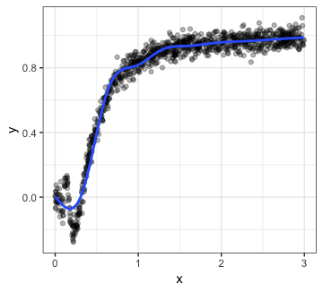

The smoother seems to be doing a good job of capturing the relationship for most of the plot, but it looks like there’s something more going on in the x \in [0, 0.5]region. Let’s zoom in:

p2 <- ggplot(df, aes(x, y)) +

geom_point(alpha = 0.3) +

geom_smooth(se = FALSE) +

scale_x_continuous(limits = c(0, 0.5)) +

scale_y_continuous(limits = c(-0.3, 0.6)) +

theme_bw()

p2

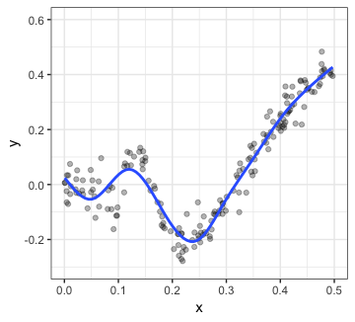

That certainly seems like a meaningful relationship! While we might want to plot p1 to depict the overall relationship, it is probably a good idea to show p2 as well. This can be achieved very easily:

p1 + annotation_custom(ggplotGrob(p2), xmin = 1, xmax = 3,

ymin = -0.3, ymax = 0.6)

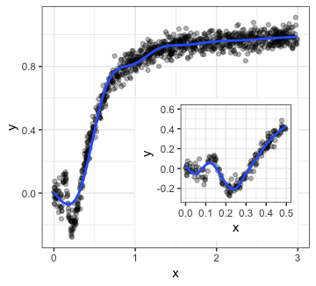

The first argument is for annotation_custom must be a “grob” (what is a grob? see details [here](https://stat.ethz.ch/R-manual/R-devel/library/grid/html/grid.grob.html)) which we can create using the ggplotGrob function. The 4 other arguments (xmin etc.) indicate the coordinate limits for the inset: these coordinates are with reference to the axes of the outer plot. As explained in the documentation, the inset will try to fill up the space indicated by these 4 arguments while being center-justified.

For ggmap objects, we need to use inset instead of annotation_custom. We illustrate this by making a map of continental USA with insets for Alaska and Hawaii.

Let’s get a map of continental US (for more details on how to use Stamen maps, see my post [here](https://statisticaloddsandends.wordpress.com/2018/10/25/getting-started-stamen-maps-with-ggmap/)):

library(ggmap)

us_bbox <- c(left = -125, bottom = 25, right = -55, top = 50)

us_main_map <- get_stamenmap(us_bbox, zoom = 5, maptype = "terrain")

p_main <- ggmap(us_main_map)

p_main

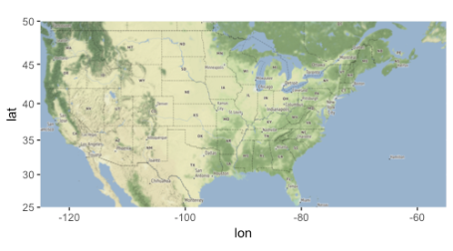

Next, let’s get maps for Alaska and Hawaii and save them into R variables. Each plot will have a title for the state, and information on the axes will be removed.

alaska_bbox <- c(left = -180, bottom = 50, right = -128, top = 72)

alaska_map <- get_stamenmap(alaska_bbox, zoom = 5, maptype = "terrain")

p_alaska <- ggmap(alaska_map) +

labs(title = "Alaska") +

theme(axis.title = element_blank(),

axis.text = element_blank(),

axis.ticks = element_blank())

p_alaska

hawaii_bbox <- c(left = -160, bottom = 18.5, right = -154.5, top = 22.5)

hawaii_map <- get_stamenmap(hawaii_bbox, zoom = 6, maptype = "terrain")

p_hawaii <- ggmap(hawaii_map) +

labs(title = "Hawaii") +

theme(axis.title = element_blank(),

axis.text = element_blank(),

axis.ticks = element_blank())

p_hawaii

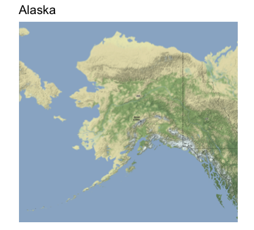

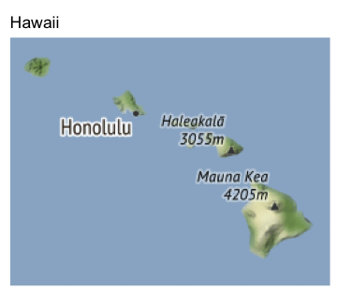

We can then use inset twice to embed these two plots (I had to fiddle around with the xmin etc. options to get it to come out right):

library(grid)

p_main +

inset(ggplotGrob(p_alaska), xmin = -76.7, xmax = -66.7, ymin = 26, ymax = 35) +

inset(ggplotGrob(p_hawaii), xmin = -66.5, xmax = -55.5, ymin = 26, ymax = 35)

